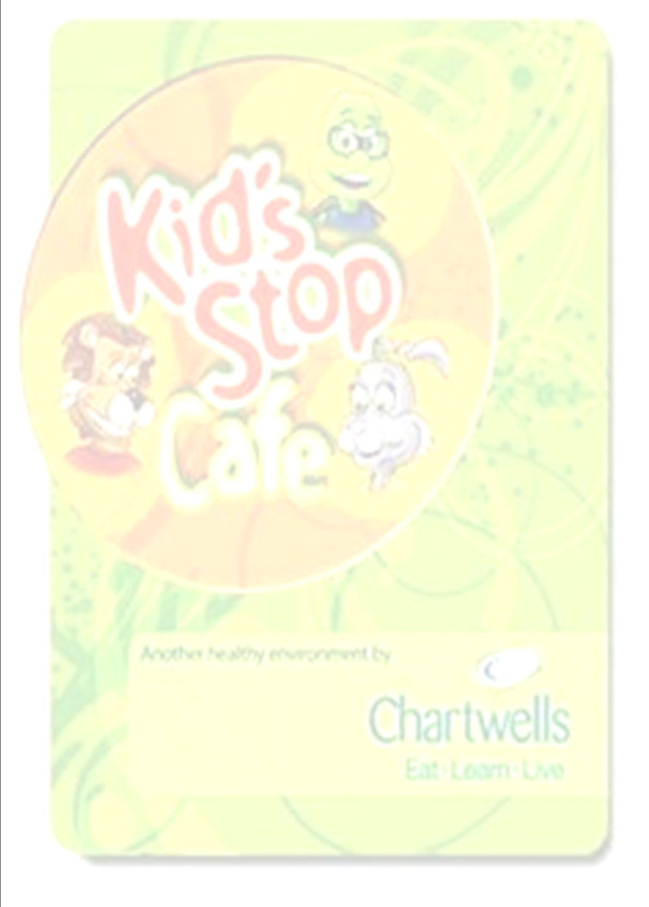


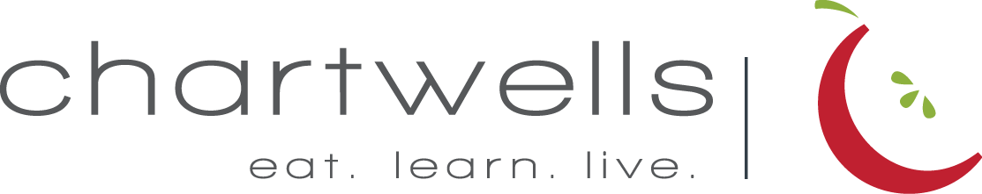

Monday | Tuesday | Wednesday | Thursday |  | Friday
Barrington Schools
October Breakfast

2  Blueberry Muffin  Choice of Fruit  Choice of Milk | 3  Whole Grain Bagel  w/ Jelly  Choice of Fruit  Choice of Milk | 4  Banana Muffin  Choice of Fruit  Choice of Milk | 5  Shri Bark Breakfast Bar  Choice of Fruit  Choice of Milk |  | 6  Strawberry Cheerios  Cereal Barr  Choice of Fruit  Choice of Milk
9  No School | 10  Whole Grain Bagel  w/ Jelly  Choice of Fruit  Choice of Milk | 11  Blueberry Muffin  Choice of Fruit  Choice of Milk | 12  Shri Bark Breakfast Bar  Choice of Fruit  Choice of Milk |  | 13  Coco puffs Cereal Bar  Choice of Fruit  Choice of Milk
16  Blueberry Muffin  Choice of Fruit  Choice of Milk | 17  Whole Grain Bagel  w/ Jelly  Choice of Fruit  Choice of Milk | 18  Banana Muffin  Choice of Fruit  Choice of Milk | 19  Shri Bark Breakfast Bar  Choice of Fruit  Choice of Milk |  | 20  Trix Cereal Bar  Choice of Fruit  Choice of Milk
23  Banana Muffin  Choice of Fruit  Choice of Milk | 24  Whole Grain Bagel  w/ Jelly  Choice of Fruit  Choice of Milk | 25  Blueberry Muffin  Choice of Fruit  Choice of Milk | 26  Shri Bark Breakfast Bar  Choice of Fruit  Choice of Milk | 27  Cinnamon Toast Crunch  Cereal Bar  Choice of Fruit  Choice of Milk
30  Blueberry Muffin  Choice of Fruit  Choice of Milk | 31  Whole Grain Bagel  w/ Jelly  Choice of Fruit  Choice of Milk
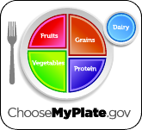
Chartwells new Food and Nutrition Guidelines make it easier than ever for students to make healthy food and beverage choices at school.
If you have any food allergies, please let us know!
USDA is an equal opportunity employer


bw.schools.nutrislice.com

